AWS Lambda
Sunday, April 13, 2025
6:54 PM

Architecture:
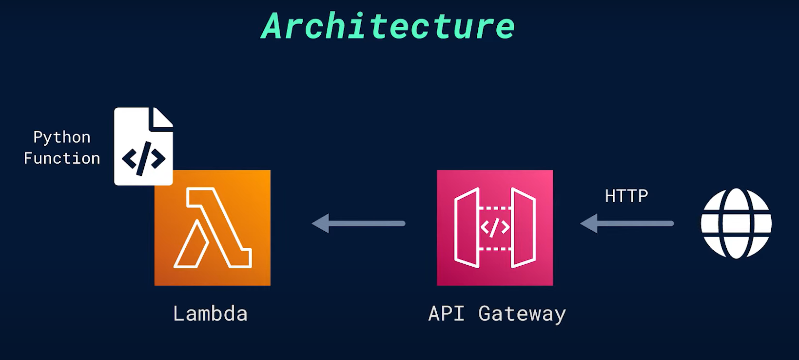

Sample program:
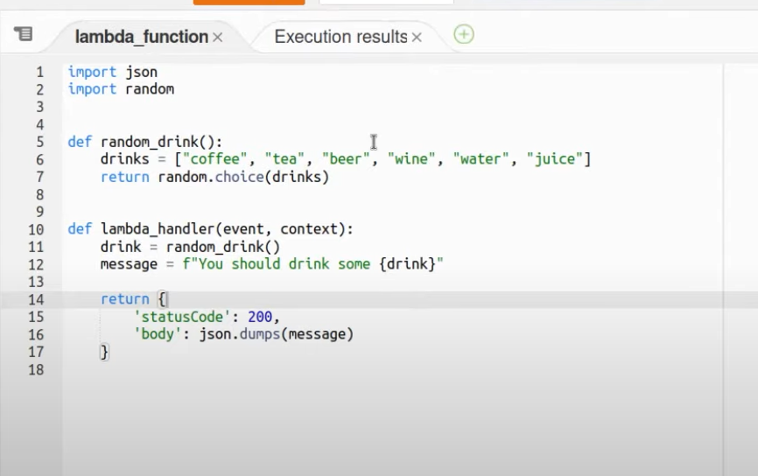

Test results:
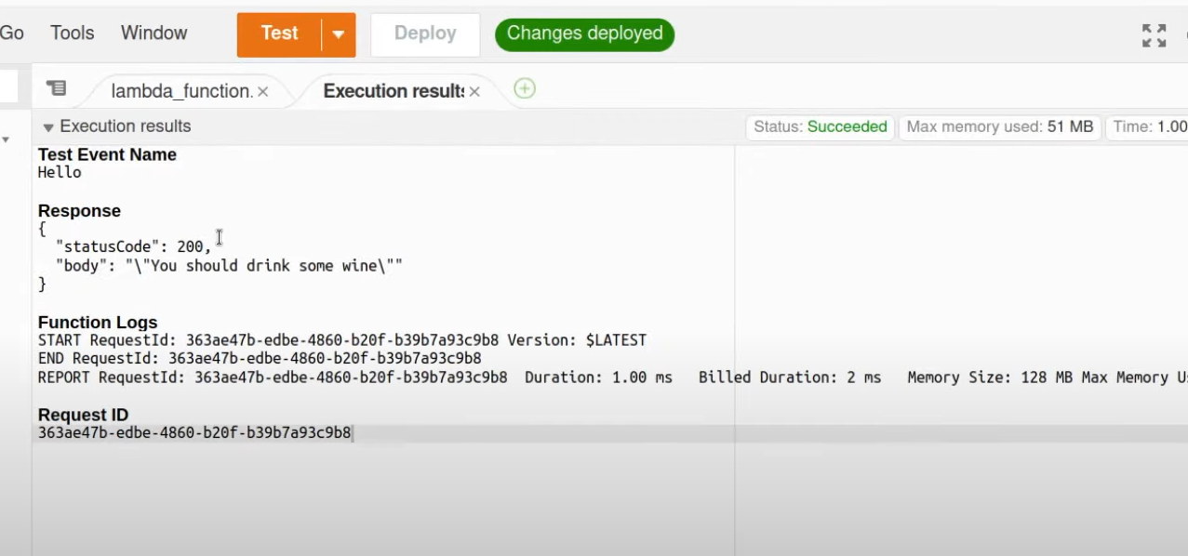

With message:
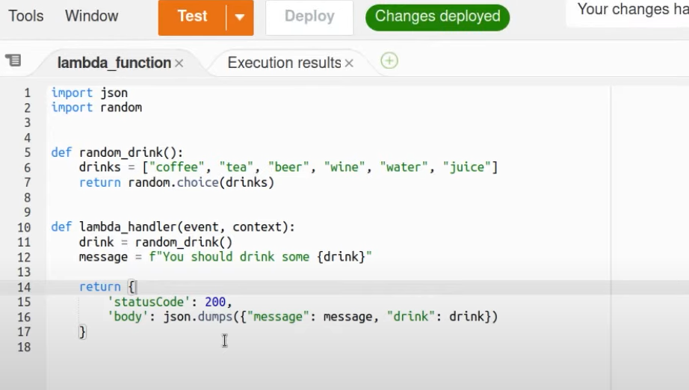

Test results:
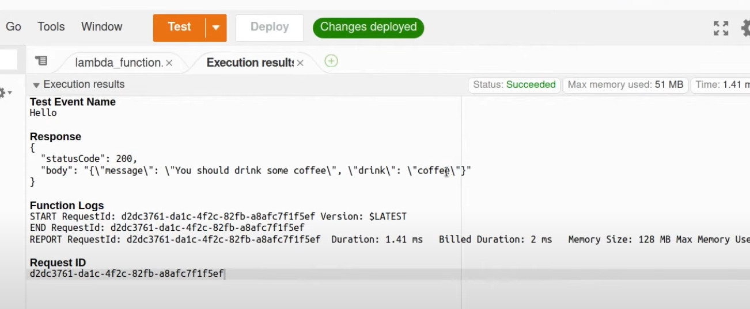

We don't really have a way to interact with it from the outside, so the way to do is we're going to add something called as "Trigger"
Trigger - which is just a way of Lambda knowing whenit should execute this function
For "Trigger", needs to use an HTTP endpoint so that we can call it from anywhere through the internet access (that could be from terminal or even the browser)
Add "API gateway" - HTTP / REST
HTTP - 71% cheaper compared to REST API

AWS Lambda (Python):
Benefits of Lambda:
- No need of managing servers
- Automatic scaling
- Pay-as-you-go pricing
- Optimization performance

Example: String-reversal
Goto Lambda (in aws console) -> functions -> create function
